Intranasal Vaccines Enable Cattle Owners to Build Immunity in Young Calves

It is important to establish an early foundation of protection against bovine respiratory disease (BRD). However, although functional, the neonatal calf immune system is immature, and it takes time to mature fully. The more we can do to help young calves build immunity within the first weeks and months of life can set them up for success.

Merck Animal Health has developed two innovative intranasal vaccines that lay the foundation for a strong, healthy and effective immune response to common respiratory diseases in calves as young as one week of age.

BOVILIS® NASALGEN® 3 and BOVILIS® NASALGEN® 3-PMH are intranasal vaccines that are effective against common pathogens that cause BRD.

BOVILIS NASALGEN 3 is effective against viral pathogens that are commonly associated with pneumonia, including bovine respiratory syncytial virus (BRSV), infectious bovine rhinotracheitis (IBR) and parainfluenza 3 (PI₃).

BOVILIS NASALGEN 3-PMH is effective against those same viruses and also two of the most common bacterial pathogens of BRD – Mannheimia haemolytica and Pasteurella multocida. It is the first and only intranasal vaccine to provide protection against all five causes of viral and bacterial pneumonia.

Both vaccines also offer a needle-free administration. A single 2 mL dose is given in one nostril.
The vaccines are BQA-friendly and have no risk of injection site reactions.

Both contain a unique BluShadow® diluent to show which animals have been vaccinated.

Because the intranasal vaccines are safe to use on calves as young as one week old and safe for use in nursing calves, they can fit into a spring turnout vaccination program. Proper vaccination in the spring can also help calves respond to vaccines given closer to or at weaning.

If you’re interested in protecting calf health with an easy-to-administer vaccine, talk to your veterinarian about how these vaccines might work for your herd or operation.

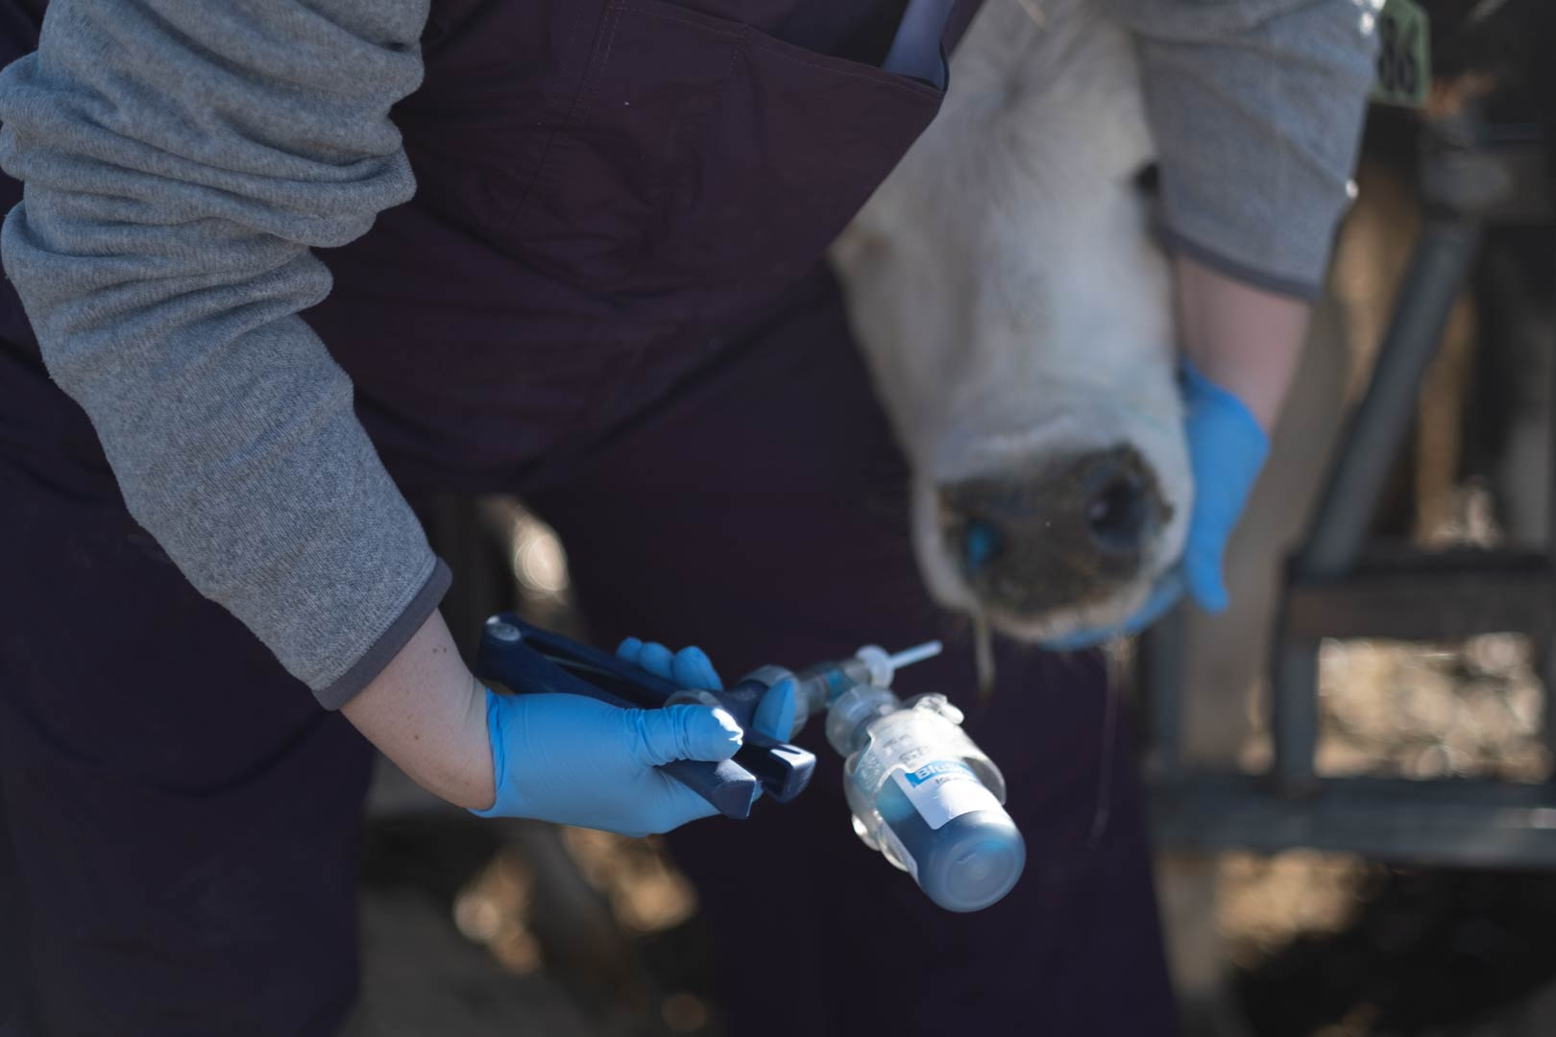
Photo caption: BOVILIS® NASALGEN® 3-PMH and BOVILIS® NASALGEN® 3 are intranasal vaccines that are effective against common pathogens that cause BRD. They are safe for calves at one week of age or older.

©2022 Merck & Co., Inc., Rahway, NJ, USA and its affiliates. All rights reserved.

